**OBSTACLE DETECTION MINI-ROBOT**

by

SANTHOSHA.A 17BEC1118

INUMELLA SRAVYA 17BEC1185

AVULA ROHITHA 17BLC1007

A project report submitted to

**Prof . SARANYA NAIR.M**

**SCHOOL OF ELECTRONICS ENGINEERING**

in partial fulfilment of the requirements for the course of

**ECE1005 – SENSORS AND INSTRUMENTATION**

in

**B.Tech. ELECTRONICS AND COMMUNICATION ENGINEERING**

**AND**

**B.Tech. ELECTRONICS AND COMPUTER ENGINEERING**



**Vellore Institute of Technology (VIT) CHENNAI**

**Vandalur – Kelambakkam Road**

**Chennai – 600127**

**MARCH 2018**

**BONAFIDE CERTIFICATE**

Certified that this project report entitled “**OBSTACLE DETECTION MINI-ROBOT”** is a bonafide work of **SANTHOSHA.A (17BEC1118),INUMELLA SRAVYA (17BEC1185)** and **AVULA ROHITHA (17BLC1007)** who carried out the Project work under my supervision and guidance.

**Prof . SARANYA NAIR.M**

Assistant Professor

School of Electronics Engineering (SENSE),

VIT University, Chennai

Chennai – 600 127.

**ABSTRACT**

In today’s world ROBOTICS is a fast growing and interesting field. ROBOT has sufficient intelligence to cover the maximum area of provided space. It has an infrared sensor which are used to sense the obstacles coming in between the path of the ROBOT. The project “Obstacle Detection Mini-Robot” deals with detection of the various obstacles found in an environment. We divided the task of creating the robot into four phases namely LED component designing, comparator, motor driver and the motors. While designing and construction of the hardware for the robot, we followed a sequential order, starting with the circuit construction of the LEDs, then designed the comparator which does the task of converting the input voltage to the output that is fed to the motor driver. The implementation of artificial intelligence (AI) logic in done in this phase, the AI logic is fed to the motor driver. The robot gathers facts about the scenario through the sensors. It then compares this information to the data stored and decides what the information signifies. The robot runs through the various possible actions and then based on the collected information it predicts which action will be most successful. The motor driver then implements the decided action and the motor helps run the robot. The robot designed was found to run successfully on an obstacle free course after being able to detect obstacles and it stops.

The building of such robots will require the developers to tackle problems such as finding efficient and effective, selection and design of circuit components keeping in mind a simple and a light-weight model that allows for smooth movement of the robot. The accuracy of the robot is dependent on the accuracy of the sensors and thus the selection of the sensors should be done keeping in mind the environment in which we want the robot to function.

Keywords: Artificial Intelligence, Obstacle detection, mobile driver ,sensors, LEDs ,Robot.

**ACKNOWLEDGEMENT**

We wish to express our sincere thanks and deep sense of gratitude to our project guide, **Prof. Saranya Nair.M,** Assistant Professor, School of Electronics Engineering, for his consistent encouragement and valuable guidance offered to us in a pleasant manner throughout the course of the project work.

We are extremely grateful to **Dr. Sreedevi. V.T,** Dean of the School of Electronics Engineering, VIT Chennai, for extending the facilities of the School towards our project and for her unstinting support.

We express our thanks to our Programme Chairs **Dr. Vetrivelan.P, Dr.Susan Elias** and Co-Chair **Prof.Reena Monica.P** for their support throughout the course of this project.

We also take this opportunity to thank all the faculty of the School for their support and their wisdom imparted to us throughout the course.

We thank our parents, family, and friends for bearing with us throughout the course of our project and for the opportunity they provided us in undergoing this course in such a prestigious institution.

**SANTHOSHA.A INUMELLA SRAVYA AVULA ROHITHA**

**TABLE OF CONTENTS**

|  |  |  |  |
| --- | --- | --- | --- |
| **SERIAL NO.** |  | **NAME** | **PAGE NO.** |
|  |  | ABSTRACT | 3 |
|  |  | ACKNOWLEDGEMENT | 4 |
|  |  |  |  |
| 1 |  | INTRODUCTION | 6 |
|  |  |  |  |
|  | 1.1 | OBJECTIVES AND GOALS | 6 |
|  | 1.2 | BENEFITS | 6 |
|  | 1.3 | FEATURES | 6 |
|  |  |  |  |
| 2 |  | DESIGN | 7-20 |
|  | 2.1 | BLOCK DIAGRAM | 7-8 |
|  | 2.2 | HARDWARE ANALYSIS | 8-20 |
|  |  |  |  |
|  |  |  |  |
|  |  |  |  |
| 3 | CONCLUSION | AND FUTURE WORK | 21 |
|  | 3.1 | RESULT, CONCLUSION AND INTERFERANCE | 21 |
|  | 3.2 | FUTURE WORK | 21 |

4 REFERENCES 22

1. **INTRODUCTION**

**1.1 OBJECTIVES AND GOALS**

* The main objective of this project is to avoid the situations that are harmful and learn ways to avoid road accidents.
* The goal of this project is to develop a obstacle detection system using IR detection sensors.
* The current project in robotics aims to build autonomous and intelligent robots, which can plan its motion in a dynamic environment.
* The project is tested on a three-wheeler robot equipped with infrared sensor to perform collision-free navigation.

**1.2 BENEFITS**

Obstacle detection mini-robots can be used as services robots, for the purpose of household work and so many other indoor applications. Equally they have great importance in scientific exploration and emergency rescue, there may be places that are dangerous for humans or even impossible for humans to reach directly, then we should use robots to help us. In those challenging environments, the robots gather information about their surroundings to detect obstacles.

**1.3 FEATURES**

* Sensory device to sense various things
* IR Transmitter to transmit signals and IR Receiver to receive signals
* Use of devices such as LEDs and batteries
* Motors to move the robot
* L293D motor driver to drive the motors

**2 OBSTACLE DETECTION MINI-ROBOT**

**2.1 BLOCK DIAGRAM**

The four main features of the basic block diagram (given below) are

* IR Sensor
* Comparator(LM393)
* Motor Driver(L293D)
* Motor

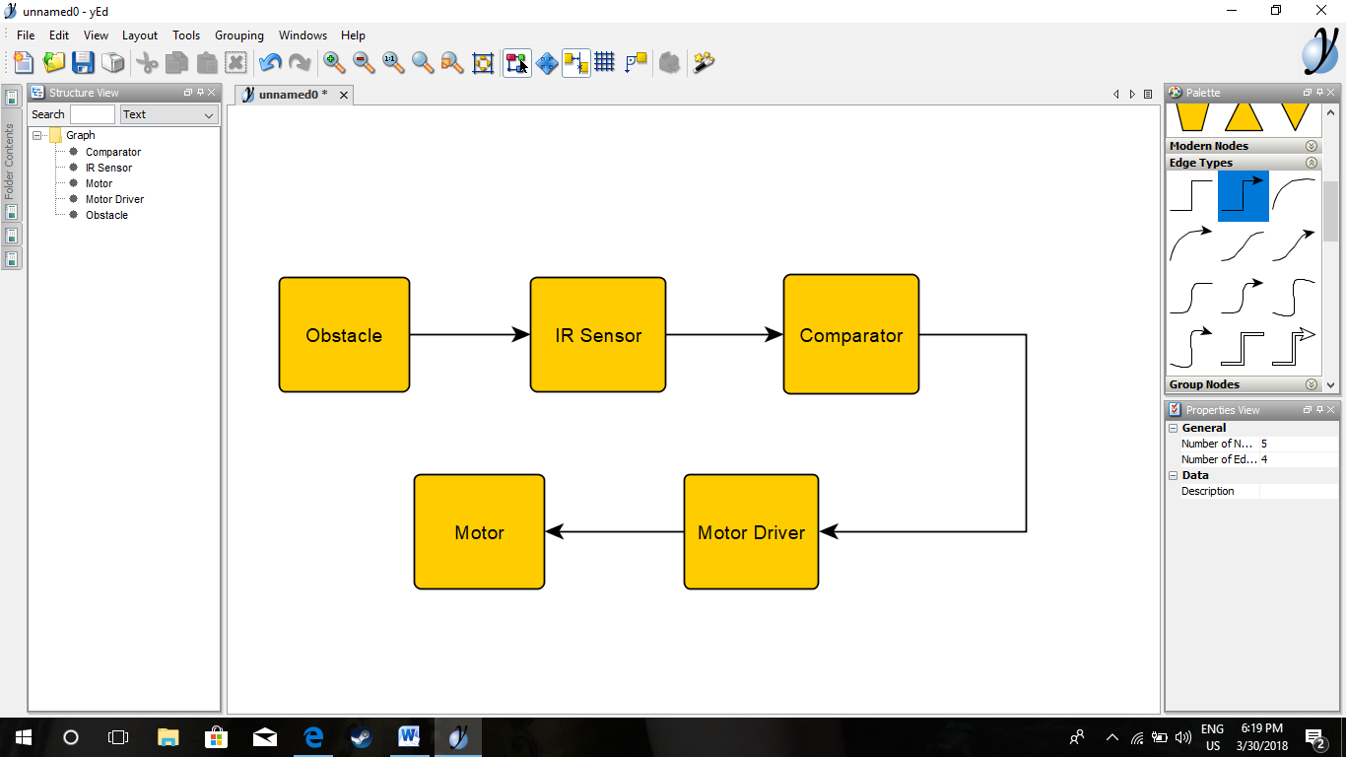

**Block Diagram**

Figure shows the way how it detects the obstacle .

**PRINCIPLE:**

The sensing component in the circuit is IR sensor, more the amount of infrared light falling on the IR sensor more is the current flowing through resistor.

Current when flows through the resistor causes potential difference to develop.The magnitude of this voltage is given by ohm’s law(V=IR).As the value of resistor is constant the voltage is directly proportional to current flowing, which in turn is directly proportional to the amount of Infrared rays incident on IR sensor. Therefore , if current increases voltage at the resistor increases.

**2.2 HARDWARE ANALYSIS**

COMPONENTS:

* IR Sensor
* Resistors
* LM393
* DC Motors
* Batteries
* Jump wires
* POT
* MOSFET
* L293D IC
* IC Socket
* Copper Clad
* Header Pins
* Wheels
* Caster wheel
* Terminal Blocks
* Switch
* Capacitor

**IR SENSOR:**

An Infrared Sensor is an electronic device, that emits in order to sense some aspects of the surroundings. An IR sensor can measure the heat of an object as well as detects the motion. These types of sensors measures only infrared radiation, rather than emitting it that is called as a passive IR sensor.

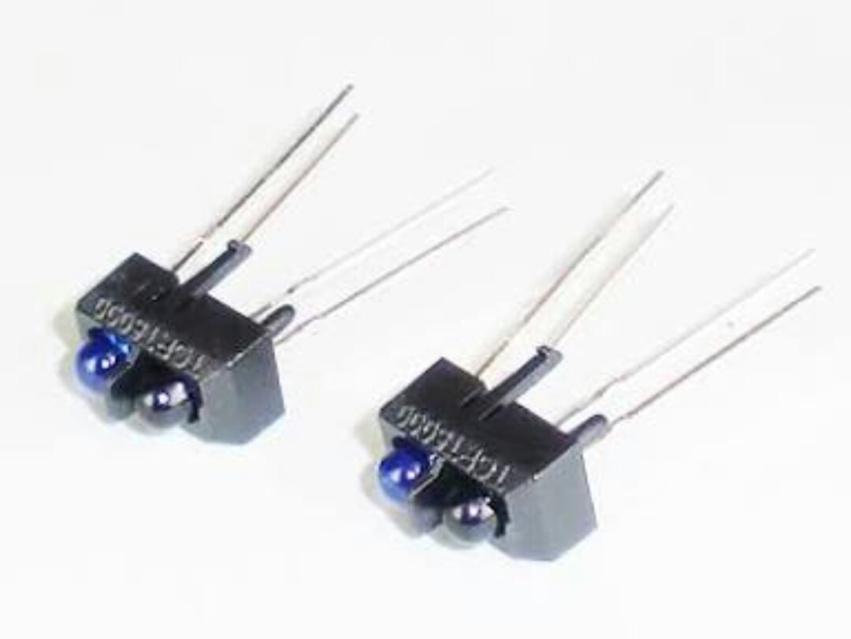

TYPES OF IR SENSORS:

Infrared sensors can be passive or active. Passive infrared sensors are basically Infrared detectors. Passive infrared sensors do not use any infrared source and detects energy emitted by obstacles in the field of view. They are of two types: quantum and thermal. Thermal infrared sensors use infrared energy as the source of heat and are independent of wavelength. Thermocouples, pyroelectric detectors and bolometers are the common types of thermal infrared detectors.

Quantum type infrared detectors offer higher detection performance and are faster than thermal type infrared detectors. The photosensitivity of quantum type detectors is wavelength dependent. Quantum type detectors are further classified into two types: intrinsic and extrinsic types. Intrinsic type quantum detectors are photoconductive cells and photovoltaic cells.

Active infrared sensors consist of two elements: infrared source and infrared detector. Infrared sources include an LED or infrared laser diode. Infrared detectors include photodiodes or phototransistors. The energy emitted by the infrared source is reflected by an object and falls on the infrared detector.

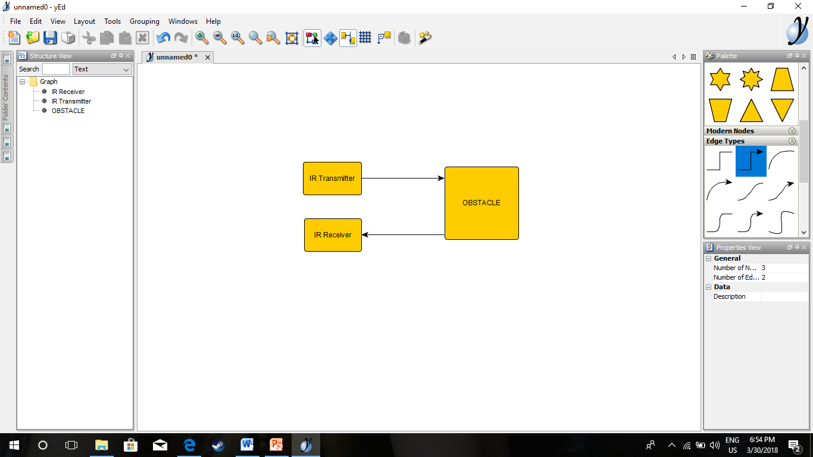

IR Transmitter:

Infrared Transmitter is a light emitting diode (LED) which emits infrared radiations. Hence, they are called IR LED’s. Even though an IR LED looks like a normal LED, the radiation emitted by it is invisible to the human eye.

The picture of a typical Infrared LED is shown below.

[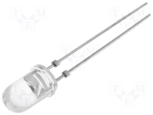](https://www.electronicshub.org/wp-content/uploads/2015/01/IR-LED.png)

There are different types of infrared transmitters depending on their wavelengths, output power and response time.

A simple infrared transmitter can be constructed using an infrared LED, a current limiting resistor and a power supply.

IR transmitters can be found in several applications. Some applications require infrared heat and the best infrared source is infrared transmitter. When infrared emitters are used with Quartz, solar cells can be made.

IR Receiver:

Infrared receivers are also called as infrared sensors as they detect the radiation from an IR transmitter. IR receivers come in the form of photodiodes and phototransistors. Infrared Photodiodes are different from normal photo diodes as they detect only infrared radiation. The picture of a typical IR receiver or a photodiode is shown below.

[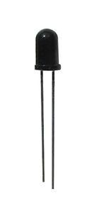](https://www.electronicshub.org/wp-content/uploads/2015/01/IR-Receiver.jpg)

Different types of IR receivers exist based on the wavelength, voltage, package, etc. When used in an infrared transmitter – receiver combination, the wavelength of the receiver should match with that of the transmitter.

**RESISTOR:**

A resistor is a passive two-terminal electrical component that implements electrical resistance as a circuit element. In electronic circuits, resistors are used to reduce current flow, adjust signal levels, to divide voltages, bias active elements, and terminate transmission lines, among other uses. High-power resistors that can dissipate many watts of electrical power as heat, may be used as part of motor controls, in power distribution systems, or as test loads for generators. Fixed resistors have resistances that only change slightly with temperature, time or operating voltage. Variable resistors can be used to adjust circuit elements (such as a volume control or a lamp dimmer), or as sensing devices for heat, light, humidity, force, or chemical activity.

Resistors are common elements of electrical networks and electronic circuits and are ubiquitous in electronic equipment. Practical resistors as discrete components can be composed of various compounds and forms. Resistors are also implemented within integrated circuits.

The electrical function of a resistor is specified by its resistance: common commercial resistors are manufactured over a range of more than nine orders of magnitude. The nominal value of the resistance falls within the manufacturing tolerance, indicated on the component.

[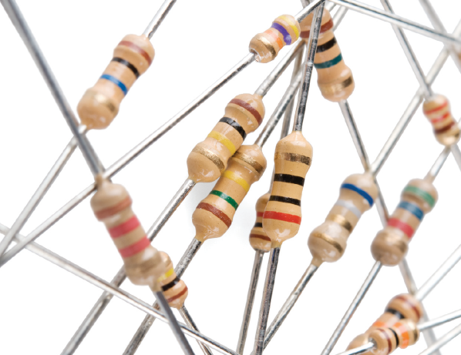](https://www.google.co.in/url?sa=i&rct=j&q=&esrc=s&source=images&cd=&cad=rja&uact=8&ved=2ahUKEwjDlKTKo5TaAhVKo48KHYjwAVwQjRx6BAgAEAU&url=https://learn.sparkfun.com/tutorials/resistors&psig=AOvVaw3cnwUrwf__Bw4W0Nomp2Gb&ust=1522507234467174)

**LM393:**

The LM393 is a low power dual operational amplifier

Integrated circuit originally introduced by National Semiconductor. It is used in detector circuits.

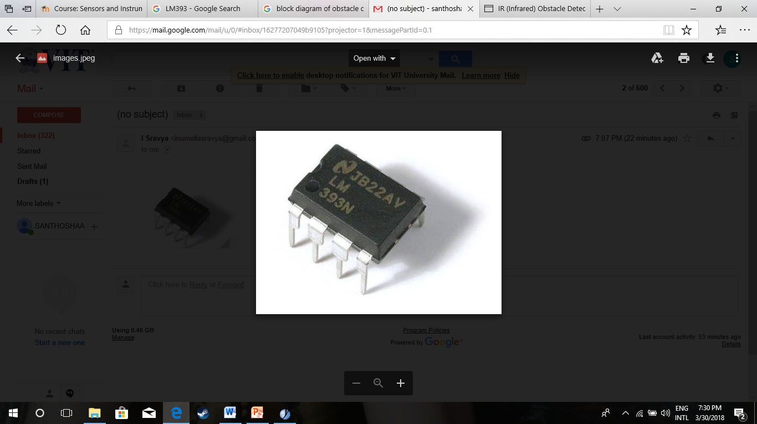

**DC MOTOR:**

A DC motor is any of a class of rotary electrical machines that converts direct current electrical energy to mechanical energy .The most common types rely on the forces produced by magnetic fields.

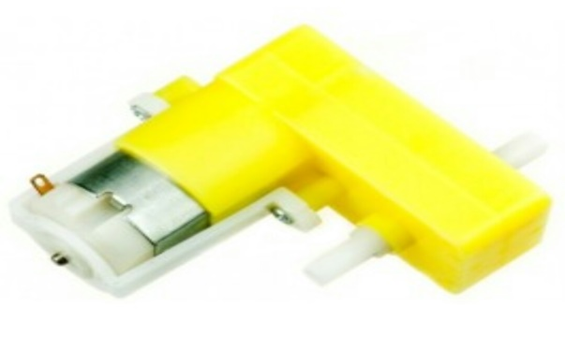

**BATTERY:**

The nine-volt battery, or 9-volt battery, is a common size of battery that was introduced for the early transistor radios. It has a rectangular prism shape with rounded edges and a polarized snap connector at the top. This type is commonly used in walkie-talkies, clocks and smoke detectors.

The nine-volt battery format is commonly available in primary carbon-zinc and alkaline chemistry, in primary lithium iron disulfide, and in rechargeable form in nickel-cadmium, nickel-metal hydride an0d lithium-ion.

[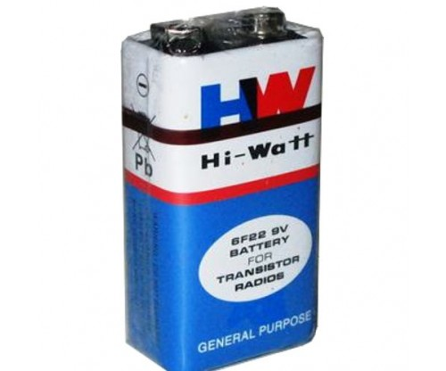](https://www.google.co.in/url?sa=i&rct=j&q=&esrc=s&source=images&cd=&cad=rja&uact=8&ved=2ahUKEwiewNvTpZTaAhWK6Y8KHSOSDqkQjRx6BAgAEAU&url=http://hobbypep.com/shop/electronic-components/hi-watt-9v-battery/&psig=AOvVaw11pCYyKHIGvaxcao1V7sce&ust=1522507790345007)

**JUMP WIRES:**

A jump wire (also known as jumper, jumper wire, jumper cable, DuPont wire, or DuPont cable – named for one manufacturer of them) is an electrical wire or group of them in a cable with a connector or pin at each end (or sometimes without them – simply "tinned"), which is normally used to interconnect the components of a breadboard or other prototype or test circuit, internally or with other equipment or components, without soldering.

Individual jump wires are fitted by inserting their "end connectors" into the slots provided in a breadboard, the header connector of a circuit board, or a piece of test equipment

[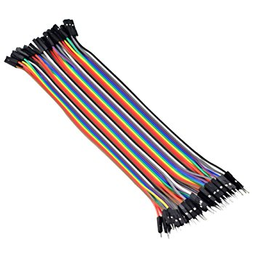](https://www.google.co.in/url?sa=i&rct=j&q=&esrc=s&source=images&cd=&cad=rja&uact=8&ved=2ahUKEwiK2eyuppTaAhXBrY8KHQ7dCM0QjRx6BAgAEAU&url=https://www.amazon.co.uk/Conductor-Female-Jumper-Color-Ribbon/dp/B00ATMHU52&psig=AOvVaw1CS9xd5R-UY5pjZzhiezat&ust=1522507976446365)

**POT:**

A potentiometer is a three-terminal resistor with a sliding or rotating contact that forms an adjustable voltage divider. If only two terminals are used, one end and the wiper, it acts as a variable resistor or rheostat.

The measuring instrument called a potentiometer is essentially a voltage divider used for measuring electric potential (voltage); the component is an implementation of the same principle, hence its name.

Potentiometers are commonly used to control electrical devices such as volume controls on audio equipment. Potentiometers operated by a mechanism can be used as position transducers, for example, in a joystick. Potentiometers are rarely used to directly control significant power (more than a watt), since the power dissipated in the potentiometer would be comparable to the power in the controlled load.

[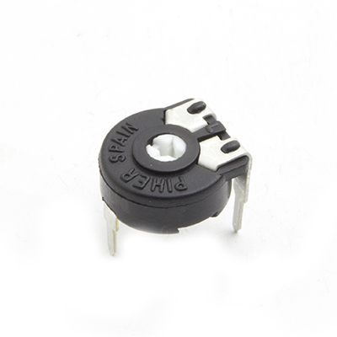](https://www.google.co.in/url?sa=i&rct=j&q=&esrc=s&source=images&cd=&cad=rja&uact=8&ved=2ahUKEwj90438ppTaAhUHP48KHcJZBSoQjRx6BAgAEAU&url=http://shop.rabtron.co.za/catalog/pt10-horizontal-trim-470k-p-357.html&psig=AOvVaw20GmbYiK2wBiAg1Ae9eiKb&ust=1522508131228367)

**MOSFET:**

The metal-oxide-semiconductor field-effect transistor (MOSFET, MOS-FET, or MOSFET) is a type of field-effect transistor (FET), most commonly fabricated by the controlled oxidation of silicon. It has an insulated gate, whose voltage determines the conductivity of the device. This ability to change conductivity with the amount of applied voltage can be used for amplifying or switching electronic signals.

[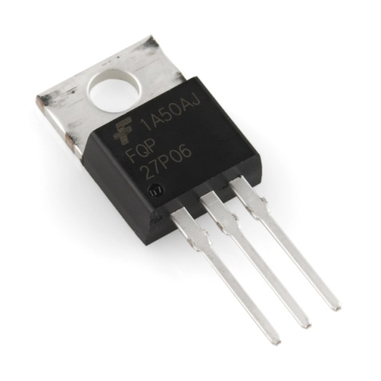](https://www.google.co.in/url?sa=i&rct=j&q=&esrc=s&source=images&cd=&cad=rja&uact=8&ved=2ahUKEwjIrs6xlpTaAhVFpo8KHR-UBtcQjRx6BAgAEAU&url=https://www.sparkfun.com/products/10349&psig=AOvVaw1n7AkXy7DHXjxUmwX20p94&ust=1522503651588185)

**L293D:**

L293D is a typical Motor driver or Motor Driver IC which allows DC motor to drive on either direction. L293D is a 16-pin IC which can control a set of two DC motors simultaneously in any direction. It means that you can control two DC motor with a single L293D IC.

The l293d can drive small and quiet big motors as well.

It works on the concept of H-bridge. H-bridge is a circuit which allows the voltage to be flown in either direction. As you know voltage need to change its

direction for being able to rotate the motor in clockwise or anticlockwise direction, Hence, H-bridge IC are ideal for driving a DC motor.

In a single l293d chip there two h-Bridge circuit inside the IC which can rotate two dc motor independently. Due its size it is very much used in robotic application for controlling DC motors. Given below is the pin diagram of a L293D motor controller.

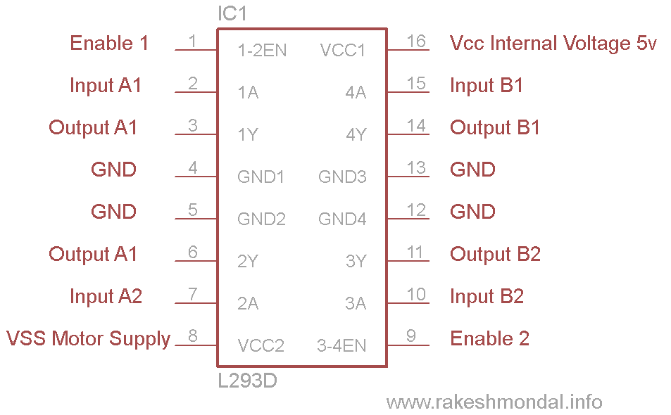

**L293D pin diagram**

There are two Enable pins on l293d. Pin 1 and pin 9, as shown in figure 5, for being able to drive the motor, the pin 1 and 9 need to be high. For driving the motor with left H-bridge you need to enable pin 1 to high. And for right H-Bridge you need to make the pin 9 to high. If anyone of the either pin1 or pin9 goes low then the motor in the corresponding section will suspend working. It’s like a switch.

**IC SOCKET:**

An IC socket, or integrated circuit socket, is used in devices that contain an integrated circuit. An IC socket is used as a placeholder for IC chips and is used in order to allow safe removal and insertion of IC chips because IC chips may become damaged from heat due to soldering.

[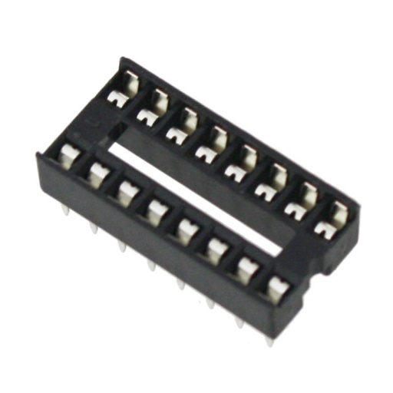](https://www.google.co.in/url?sa=i&rct=j&q=&esrc=s&source=images&cd=&cad=rja&uact=8&ved=2ahUKEwiRuMr-opTaAhXLNo8KHR0iBT8QjRx6BAgAEAU&url=https://www.kitronik.co.uk/2932-ic-socket-16-pin-tube-of-30.html&psig=AOvVaw3-pUFOwVeO4SzxqL6e3chB&ust=1522507062677555)

**COPPER CLAD:**

Copper-clad steel (CCS), also known as copper-covered steel or the trademarked name Copperweld is a bi-metallic product, mainly used in the wire industry that combines the high mechanical resistance of steel with the conductivity and resistance to corrosion of copper.

[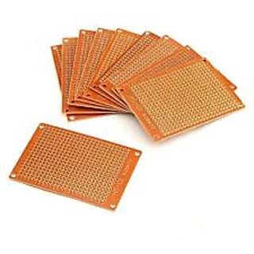](https://www.google.co.in/url?sa=i&rct=j&q=&esrc=s&source=images&cd=&cad=rja&uact=8&ved=2ahUKEwio_bDKp5TaAhWBLo8KHXXEBL0QjRx6BAgAEAU&url=https://www.shopclues.com/pcb-3-pieces-copper-clad-general-purpose-circuit-board-140x90mm-with-holes..html&psig=AOvVaw2lclB1lviRUjLhjIJTN8Jf&ust=1522508307469877)

**HEADER PINS:**

A pin header (often abbreviated as PH, or simply header) is a form of electrical connector. It consists of one or more rows of male pins typically spaced 2.54 millimetres (0.1 in) apart, but common sizes also include 5.08 millimetres (0.2 in), 5.00 millimetres (0.197 in), 3.96 millimetres (0.156 in), 2.00 millimetres (0.079 in), 1.27 millimetres (0.05 in) and 1.00 millimetre (0.04 in).The distance between pins is commonly referred as pitch in the electronic community.

[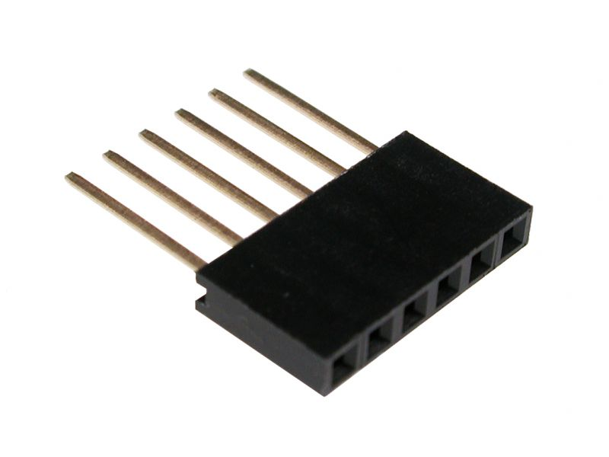](https://www.google.co.in/url?sa=i&rct=j&q=&esrc=s&source=images&cd=&cad=rja&uact=8&ved=&url=https://solarbotics.com/product/fpin6l_413/&psig=AOvVaw1FPkcsXCaAavOOUkFhGgs3&ust=1522508530701978)

**CASTER WHEEL:**

A caster is a wheeled device typically mounted to a larger object that enables relatively easy rolling movement of the object. Casters are essentially special housings that include a wheel, facilitating the installation of wheels on objects. Casters are found virtually everywhere, from office desk chairs to shipyards, from hospital beds to automotive factories. They range in size from the very small furniture casters to massive industrial casters, and individual load capacities span 100 pounds (45 kg) or less to 100,000 pounds (45 t). Wheel materials include cast iron, plastic, rubber, polyurethane, forged steel, stainless steel, aluminium, and more.

[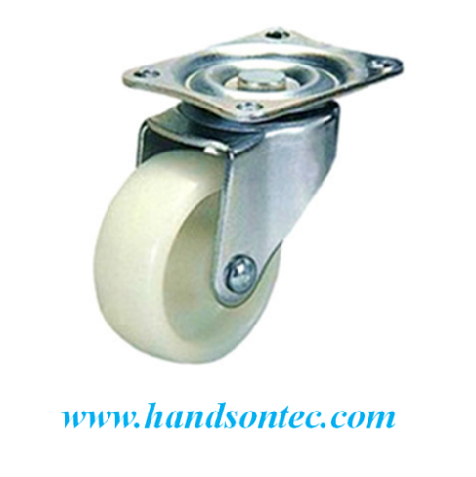](https://www.google.co.in/url?sa=i&rct=j&q=&esrc=s&source=images&cd=&cad=rja&uact=8&ved=2ahUKEwjVr6WsqZTaAhXFMo8KHVPwBZQQjRx6BAgAEAU&url=http://handsontec.com/index.php/product/1-inch-swivel-caster-wheels-for-robotics-car/&psig=AOvVaw1DbTK8J9rx8EghsU8yAyzV&ust=1522508777119253)

**TERMINAL BLOCK:**

Terminal blocks are modular, insulated blocks that secure two or more wires together. Terminal blocks are used to secure and/or terminate wires and, in their simplest form, consist of several individual terminals arranged in a long strip. Terminals are useful for connecting wiring to a ground or, in the case of electrical power, for connecting electrical switches and outlets to the mains.

Terminal bodies typically consist of a copper alloy with the same expansion coefficient as the wire intended for use. This not only prevents loosening because of differing expansion rates but also reduces corrosion caused by electrolytic action between two different metals.

[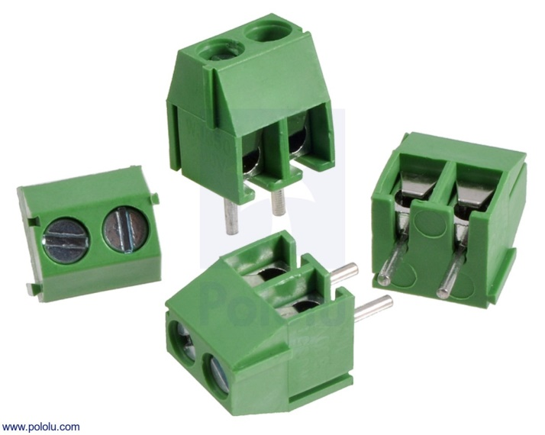](https://www.google.co.in/url?sa=i&rct=j&q=&esrc=s&source=images&cd=&cad=rja&uact=8&ved=2ahUKEwiW_qWyqpTaAhUhT48KHSlTCoYQjRx6BAgAEAU&url=https://www.pololu.com/product/2444&psig=AOvVaw1ypO8FrsWxWA685mX9S9m-&ust=1522509051456530)

**SWITCH:**

In electronics, an electronic switch is an electronic component or device that can switch an electrical circuit, interrupting the current or diverting it from one conductor to another. Typically, electronic switches use solid state devices such as transistors, though vacuum tubes can be used as well in high voltage applications.

[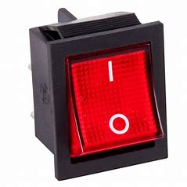](https://www.bing.com/images/search?view=detailV2&ccid=roC9AOJZ&id=62B0E22B0E1F90B89822CA34536794CBD70E49E1&thid=OIP.roC9AOJZp8vlIqvbeWV0lwHaHa&mediaurl=http://www.webstaurantstore.com/images/products/main/157550/314503/carnival-king-replacement-on-off-switch-for-pm30r-royalty-series-popcorn-popper.jpg&exph=1000&expw=1000&q=On+Off+Switch&simid=608012121144428879&selectedIndex=3)

**CIRCUIT DIAGRAM:**

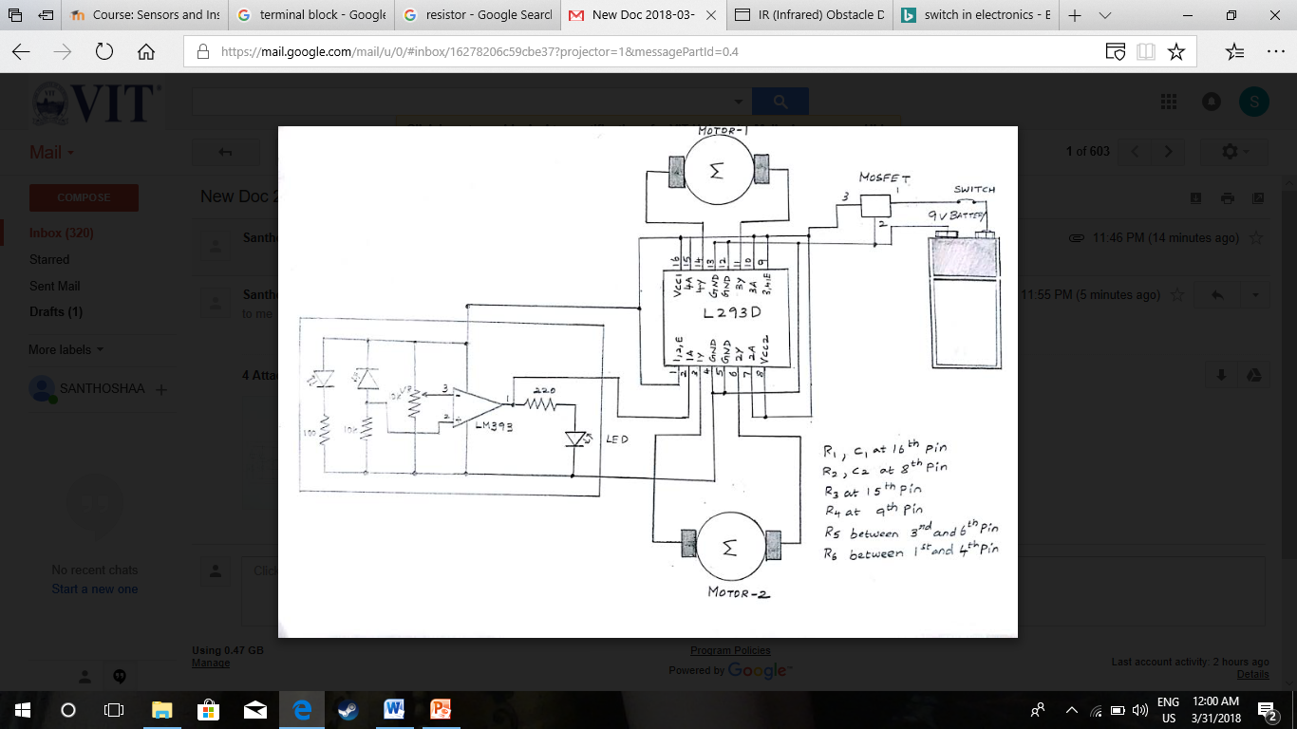

**PROJECT DESCRIPTION:**

This is a concept of very simple robot toy. Two wheels are used to move the robot toy. One IR Proximity sensor detects the presence of any obstacle and switch on the motors. In this project the transmitter section includes an IR Sensor which transmits the continuous IR rays to be received by an IR receiver module. IR output terminal of the receiver varies depending upon the receiving of IR rays. Since this variation cannot be analysed as such, therefore this output can be fed to comparator circuit. When the IR receiver does not receive the signal, the potential at the inverting input goes higher than the non-inverting input of LM393. Thus the output of comparator goes slow. When the IR receiver module receives signal to the potential at inverting input goes low. LM293D is a dual H-bridge motor driver integrated circuit(IC). Motor drivers act as current amplifiers since they take low current control signal and provide a higher current signal. This higher current signal is used to drive the motors.

**PROJECT MODEL:**

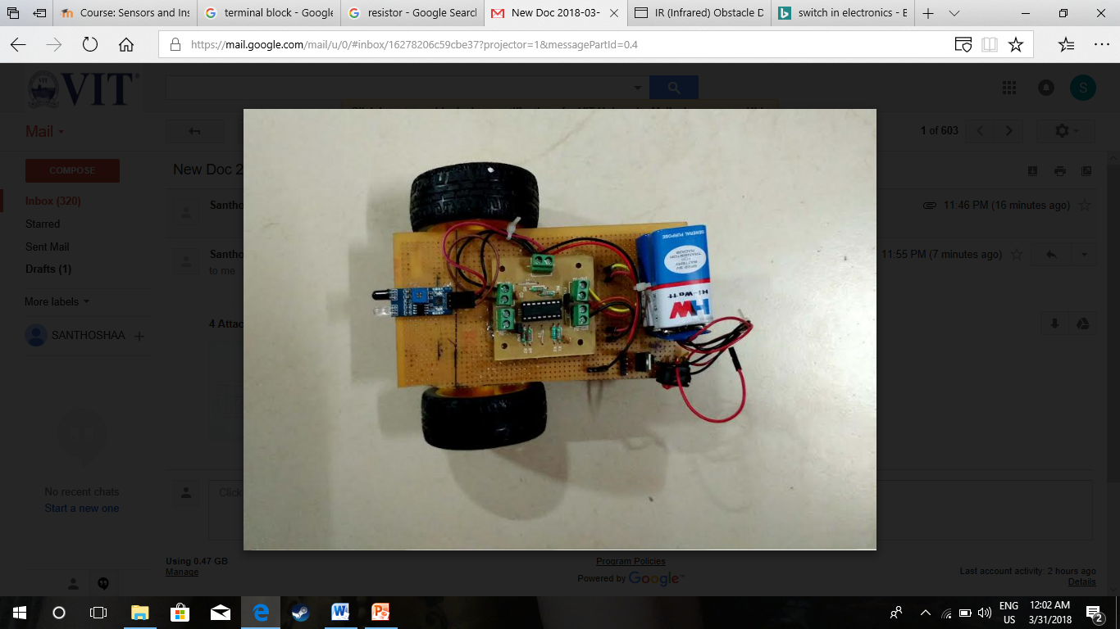

**3. CONCLUSION AND FUTURE WORK**

**3.1 CONCLUSION**

From this study, a walking robot that achieved the stated objectives had been developed. This robot is able to produce the basic walking movements using two gear motors. We developed the robot with a very good intelligence which is easily capable to sense the obstacle  and by processing the signal coming from the sensor it perfectly detects the obstacle coming in between the path. Robot takes the forward movement or stops in according to the sensing signal with the help of the two gear motors which makes the movement of the robot smooth .In future, the sensing range can be increased  by increasing the sensor quality with the help of ultrasonic sensor or the IR signal spread all over the provide area.

**3.2 FUTURE WORK**

* Adding a camera: If the current project is interfaced with a camera robot can be driven beyond line of sight and range becomes practically unlimited as networks have a very large range.
* Adding a temperature sensor: By adding temperature sensor, we can use this robot as fire-fighting robot.

**4. REFERENCES**

1. [www.google.com](http://www.google.com)
2. <http://www.instructables.com/>
3. [www.circuitstoday.com](http://www.circuitstoday.com)
4. [www.fadooengineers.com](http://www.fadooengineers.com)
5. [www.electroschematics.com](http://www.electroschematics.com)
6. [www.engineersgarage.com](http://www.engineersgarage.com)
7. [www.wikipedia.com](http://www.wikipedia.com)
8. [www.electrosome.com](http://www.electrosome.com)
9. <https://www.electronicshub.org/ir-sensor/>
10. <https://youtu.be/qEMtCKfZOHw>
11. <https://www.elprocus.com/infrared-ir-sensor-circuit-and-working/>